Vessel Tracking System (VTS) Project
Project Plan
Filing Reference : | ISS/VTS/MP.2/1
Document Title : | Project Plan
Version : | 1.0
Prepared By : | Teng Boon Wee
Date Created : | Saturday, March 20, 2010

Approved By :
 | Kyaw Thu Lin | Date
 | QA Manager
Authorised By :
 | Chong Imm Lam | Date
 | User Manager

Document Reference : ISS/FCS2/MP.2/1
©1993 ISS.  The information contained in this document is the property of ISS. The contents must not be reproduced, wholly or in part, for purposes other than for which it has been supplied, without the prior permission of ISS, or, if it has been furnished under contract to another party, as expressly authorised under that contract. ISS shall not be liable for any errors or omissions. | ISS
Version | Date | Author | Authorised by | Date
1.0 | 20/3/2010 | Teng Boon Wee | Chong Imm Lam

Vessel Tracking System (VTS) Project
Project Plan
Distribution :
Name | Department | Organisation
Teng Boon Wee | - | ISS
Li Pengfei | - | ISS
Cai Xiang | - | ISS
Erik Araojo | - | ISS
Kyaw Thu Lin | - | ISS
Naung Naung Latt | - | ISS
Oh Chew Key | - | ISS
Plathottam Linu Thankam | - | ISS
Chong Imm Lam | SEG | ST Electronics
Table of Contents.

1. INTRODUCTION 1
1.1. Purpose 1
1.2. Audience 1
1.3. Organisation 1
1.4. References 1
2. APPROACH 2
2.1. Project Initiation 2
2.2. Requirements Gathering 2
2.3. Design 2
2.4. Software Implementation 2
2.5. Testing 3
3. WORK PLAN 3
3.1. Activity 1 – Management and Administration 3
3.2. Activity 2 - Requirements Identification 4
3.3. Activity 3 – Functional Specification 5
3.4. Activity 4 – High Level Design 5
3.5. Activity 5 – Prototype Development 5
3.6. Activity 6 – Detailed Design 6
3.7. Activity 7 – Software Coding 6
3.8. Activity 8 – Software Testing 6
3.9. Activity 9 – Documentation 6
3.10. Activity 10 – User Acceptance 7
4. STAFF EFFORT ESTIMATES 8
5. TIMESCALES AND MILESTONES 8
6. DELIVERABLES 16
7. PROJECT TEAM STRUCTURE AND RESPONSIBILITIES 16
7.1. Project Manager : Teng Boon Wee 16
7.2. Software Architect: Cai Xiang 16
7.3. Test Manager: Plathottam Linu Thankam 16
7.4. Quality Manager: Kyaw Thu Lin 17
7.5. Configuration Manager: Oh Chew Key 17
7.6. Integration Manager: Naung Naung Latt 17
7.7. Technical Writer: Erik Araojo 17
7.8. Software Lead/Business Analysis: Li Pengfei 17
8. RESOURCES 18
8.1. Accommodation 18
8.2. Computer Hardware and Software 18
9. Project Estimate 18
10. Risk Assessment and Management 18

INTRODUCTION
ST Electronics (Info-Software Systems) Pte Ltd has requested for a software system which can be used for the purpose of vessel tracking. The system must be developed using Java, and will be used as a foundation system on which future Java based vessel tracking systems will be based upon.

Purpose
The purpose of this document is to provide a Project Plan for the work to complete this project to develop the Vessel Tracking System.

Audience
The intended readers of this Project Plan are the project team to:
1. provide them with a plan for the activities that they are to perform;
2. specify the deliverables they are to produce and;
3. indicate the required effort budgets and timescales.

Organisation
The approach to be adopted by the project to carry out the work is summarised in Section 2 and major activities are identified in Section 3. Staff effort estimates to undertake the work are defined in Section 4 and timescales are given in Section 5. Section 6 describes the deliverables and Section 7 gives details of the project's structure and staffing. Finally, the resources required to support the work are specified in Section 8.

References
To fully understand the background to this project, the reader should also be familiar with the Vessel Tracking System Quality Plan (reference ISS/VTS/MQ.1/1).

APPROACH
The approach that will be applied to the development of the Vessel Tracking System will be to carry out the development phases outlined below.

Project Initiation
To initiate the project, a formal project plan will be produced (this document). Subsequently, a QA plan will be produced. To complete the project initiation tasks, a project filing system will be set-up.

Requirements Gathering
The intial requirements from the users will be captured in this phase. The Business Analyst will gather the initial requirements from the users and document them. The requirements will then be represented in the form of use cases, showing the work flow of the tasks that the system is supposed to perform.
The User Interface Specification document will also be done during this phase, and submitted to the users for approval.
The project will possibly make use of various technologies (example - GIS APIs, Application Server software). Therefore a technical feasibility study will be conducted in this phase to analyse the various technologies that can be used to fulfill the user requirements, and assess their suitability.

Design
Analysis of the use cases will be done in this phase to eventually produce the design of the system. The use cases will be converted into a set of classes during use case realization. A transition strategy will be produced to ensure the classes are adapted for the implementation platform. Sequence diagrams will be produced to capture the interaction between the classes.
Prototyping will also be done during this phase to iron out any possible problems that may exist in the design.

Software Implementation
During this phase the design from the previous phase will be coverted to actual codes. Unit testing will also be done during this phase for each component completed.
After the components are completed and unit testing has been done for these components, the components are then integrated.

Testing
A System Test Plan will be produced. After integration has been done for the components, the test cases will be run on the entire integrated system to check for bugs and errors.

WORK PLAN
The following work program has been identified to complete the development of the system according to the approach described in Section 2.
Activity 1 : Management and Administration
Activity 2 : Requirements Identification
Activity 3 : Prototype Development
Activity 4 : Software Design
Activity 5 : Software Coding
Activity 6 : System Testing
Activity 7 : Documentation
Activity 8 : User Acceptance

Activities 2 through 8 contain the technical activities required to produce the system. Activity 1 provides the supporting management and administrative activities. The work to be performed in each activity is described in the following subsections.

Activity 1 – Management and Administration

This activity covers the project planning, management and administration activities required to support the technical project tasks. The following tasks are to be involved.

Project Kickoff Meeting
The team will be briefed on the main objectives of the project, and given an explaination of the requirements gotten from the users so far. A short introduction of the domain will also be given, to familiarize the team members with the domain.
During the project kickoff meeting, each team member will be assigned a role in the project, and will be briefed on his/her responsibilities.

Set-up Filing System
The project filing system for management and technical files will be set- up in accordance with the pre-defined standards.

Production of Project Plan
This activity involves the detailed planning of the project, resulting in the production of this document (ref ISS/VTS/MP.2/1). It consists of work breakdowns, staff effort estimates, resource requirements, time schedules, milestones and deliverables.

Production of Project Quality Plan
A project quality plan (ref ISS/VTS/MQ.1/1) will be produced to specify how the project will assure the quality of its deliverables, and its main mechanism by which the project is monitored and managed for quality assurance. In particular, the plan will specify the standards and procedures that will be applied to the project's technical and management activities, and will detail the reviews to be performed and the acceptance procedure for each deliverable.

Setup Repository Enviroment
A repository will be set up to hold the documents and source codes that will be produced during the project. During the project, the team will make use of a source version program to manage the creation and updating of the documents and source codes. Therefore during this activity, the repository will set up with the necessary file structure and access will be given to the team members.

End of Project Report
This activity will be done at the very end of the project, when all other tasks have been completed. A report will be produced to summarize the entire implementation of the project, compared to the initial planned implementation. Any changes made along the way will also be highlighted in the project.

General Management and Administration
This activity covers all aspects of the general management and administration of the project to be performed. The following tasks will be involved.
1. detailed planning of activities;
2. progress reporting;
3. production of meeting minutes;
4. project tracking; and
5. the maintenance of the project filing system.

Activity 2 - Requirements Identification
After the preliminary user meeting, a high level user requirement specification will be produced for the user to verify the user requirements.
Based on the requirement specification produced in Acitivity 1, the user interfaces will be designed and documented. These user interfaces will then be verified by the user.
The project will be implemented using several different third party technologies. In order to determine the most suitable technologies to be used, a technical feasibility study will be conducted on several selected technologies. At the end of the study, a report will generated with recommendations on the most suitable technologies. This report will then be verified by the user.

Activity 3 – Functional Specification
After the user requirements have been firmed up, the team will proceed to perform analysis of the requirements.

Use Case Modeling
The behavior of the system is modeled as a set of use cases. The use cases will reflect the user requirements as captured during the Requirements Analysis. The use cases will be documented in a Use Case Model Survey document.

Use Case Analysis
The use cases produced during use case modeling will be examined and will be represented by classes. The attributes of the classes, and the interactions between the classes will be documented in a Use Case Realization Report document.

Activity 4 – High Level Design

Produce Transition Strategy
The changes that must be made to the analysis model produced during the this phase so that it can ported to the implementation environment will be documented in the Transition Strategy document.

Produce Software Architecture
The software architecture wil be produced during this activity. The architecture will contain descriptions of the platform the system will be running on, including the hardware, operating system as well as the network layout.

Activity 5 – Prototype Development
Prototypes of portions of the system will be produced based on the designs obtained from activity 4. The prototypes wil be submitted to the user for approval, to ensure that the software design will meet the user’s expectations. A report of the findings obtained from producing the prototypes will be generated.

Activity 6 – Detailed Design
Based on the Transition Strategy, the analysis model will be modified to suit the implementation environment. The sequence diagrams as well as the object specifications will also be added in during this activity. The final design will form the Design model, and will be documented in the Design Model Report.

Activity 7 – Software Coding
When the design for the system has been completed, the actual coding of the software will begin based on the design. Unit testing will be done on completed code modules, wherever appropriate.

Activity 8 – Software Testing
To exercise quality control over the software produced, various testing procedures will be carried out. The following tasks will be performed.

Test Planning
The testing work to be performed will be formally planned, resulting in the production of a system test plan document. This document will define the tests to be performed to demonstrate all the circumstances in which the software is required to operate, as specified in the system specification. Any standards and guidelines that are required for carrying out the tests will also specified in the plan.

System Testing.
The runs of the software, defined in the system test plan, will be undertaken, checked and documented in the system testing work file. Any errors detected during testing will be corrected and the appropriate tests will be re-run to demonstrate that the software is operating correctly.

Activity 9 – Documentation
As part of the deliverables, a user manual will be produced. The user manual will detail the installation and setting up of the system. The user manual will also document all the features in the system and the procedures to correctly operate these features.

Activity 10 – User Acceptance
The last phase of the development will involve the user verifying that the system’s functionalities work as specified in the requirements, and is free from errors. The following tasks will be done for this:

Test Planing
The test setup, sets of test cases to be performed and the acceptance criteria for the User Acceptance Test will be planned, and documented as a Acceptance Test Plan. The test cases will be designed specifically for the requirements, thus allowing the user to verify that all the requirements have been fulfilled. The Acceptance Test Plan will be delivered to the user for approval before it will be used.

System Installation
The system will be installed onto a target machine on which the User Acceptance Test will be conducted.

User Acceptance Test
The User Acceptance Test will consist of the user going through the test steps documented in the Acceptance Test Plan, and recording the results of these steps in a User Acceptance Test Records document.
After the testing has been completed, the results recorded in the User Acceptance Test Records document will be reviewed. Based on the records, It will then be determined if the system has successful fulfilled all the user requirements. If it is agreed that the system has done so, the User Acceptance Test is completed and the next step will be to proceed with the User Acceptance Test signoff. Otherwise corrective actions will be planned and a retest will be carried out after these corrective actions have been implemented.

User Acceptance Test Signoff
After the User Acceptance Test has been successfully completed, a User Acceptance Test Report will generated, summarizing the User Acceptance Test and the results. The user will sign off the User Acceptance Test Report to confirm that the results are as stated in the report, and that the system has been formally accepted by the user.

STAFF EFFORT ESTIMATES
Estimates of the staff effort required to undertake the activities described in Section 3 are given in Figure 4.1.

TIMESCALES AND MILESTONES
The timescales for the activities described in Section 3 using the staff effort specified in Section 4 are given in Figure 5.2 to Figure 5.7. From these timescales, major milestones have been identified, as shown in Figure 5.1.
Figure 4.1 : Staff Effort Estimates and Progress.

 | Task
 | Task | PM | SA | TM | QM | CM | IM | TW | SL
1 | Management and Administration
1.1 | Project kickoff | 1 | 1 | 1 | 1 | 1 | 1 | 1 | 1
1.2 | Set-up filing system |  |  |  | 1
1.3 | Produce Project Plan | 4 |  |  | 1
1.4 | Review/finalize Project Plan | 1 | 1 | 1 |  | 1 |  |  | 1
1.5 | Produce Quality Plan |  |  |  | 4
1.6 | Review/finalize Quality Plan | 1 | 1 | 1 | 1 | 1 |  |  | 1
1.7 | Setup Respository Enviroment |  |  |  |  | 2
1.8 | End of Project Report | 2
1.9 | General Management and Administration | 6 | 6 | 6 | 6 | 6 | 6 | 6 | 6
2 | Requirements Identification
2.1 | Interview Users |  |  |  |  |  |  |  | 2
2.2 | Produce User Requirement Specification |  |  |  |  |  |  |  | 2
2.3 | Prototype User Interface |  |  | 2 |  |  | 2
2.4 | Produce User Interface Specification |  |  | 1 |  |  | 1
2.5 | Undertake Technical Feasibility Study |  | 2 |  |  | 2 |  |  | 2
2.6 | Produce Technical Feasibility Study Report |  | 1 |  |  | 1 |  |  | 1
2.7 | Review/finalize Requirements documentation | 2 | 2 | 2 | 2 | 2 |  |  | 2
3 | Functional Specification
3.1 | Undertake Use Case Modeling |  |  |  |  |  |  | 2
3.2 | Produce Use Case Model Survey |  |  |  |  |  |  | 1
3.3 | Identify Domain Objects/Attributes |  |  |  | 2 | 2 |  | 2
3.4 | Produce Class/Collaboration diagrams |  |  |  | 1 | 1 |  | 1
3.5 | Write Use Case Realization Reports (Analysis) |  |  |  |  |  | 1 | 1
3.6 | Review/finalize Functional Specification | 2 | 2 |  | 2
4 | High Level Design
4.1 | Produce Transition Strategy | 1 | 1
4.2 | Produce Software Architecture Document | 2 | 2
4.3 | Review/finalize High Level Design Specificaion | 4 |  |  |  |  | 4 | 3 | 3
5 | Prototyping
5.1 | Create prototypes | 3 | 3 |  |  |  |  |  | 3
5.2 | Produce Prototyping Study Report | 1 | 1 |  |  |  |  |  | 1
5.3 | Review/finalize Prototyping Study Report | 1 | 1 |  |  | 1 |  |  | 1
6 | Detailed Design
6.1 | Adjust objects to implementation architecture |  |  |  | 0.5 |  |  | 0.5
6.2 | Define object associations (static/ dynamic/creation) |  |  |  | 0.5 |  |  | 0.5
6.3 | Produce Sequence Diagrams |  |  |  | 1 |  |  | 1
6.4 | Specify object attributes/operations |  |  |  | 0.5 |  |  | 0.5
6.5 | Structure object model for implementation |  |  | 0.5 | 0.5 |  |  | 0.5
6.6 | Produce Design Model Report | 3 |  | 2 | 2 |  |  | 2
6.7 | Review/finalize Design Model Report |  | 3 | 3 | 3 | 3 |  | 3 | 3
7 | Programming
7.1 | Create Java code | 3 | 6 | 6 | 6 | 6 | 6 | 6 | 6
7.2 | Unit Testing | 2 | 4 | 4 | 4 | 4 | 4 | 4 | 4
8 | Systems Testing
8.1 | Produce Systems Test Plan |  |  | 4 |  |  | 4
8.2 | Review/finalize Systems Test Plan | 2 |  | 2 |  | 2 | 2
8.3 | Perform Systems Testing | 2 | 2 | 2 | 2 | 2 | 2 | 2 | 2
8.4 | Review Results/Corrective Action | 1 | 1 | 1 | 1 | 1 | 1 | 1 | 1
9 | Documentation
9.1 | Write User Guide |  |  |  |  | 3 |  | 3
9.2 | Review/finalize User Guide | 1 | 1 |  |  | 1 |  | 1
9.3 | Produce Installation Guide |  |  | 1 |  | 1 | 1
9.4 | Review/finalize Installation Guide | 1 |  | 1 |  |  | 1
10 | User Acceptance
10.1 | Write Acceptance test plan |  |  | 2 |  |  | 2
10.2 | Review/finalize Acceptance test plan |  |  | 1 | 1 |  | 1 | 1
10.3 | System Installation |  |  |  |  |  | 1 |  | 1
10.4 | Perform Acceptance Test | 1 | 1 | 1 | 1 | 1 | 1 | 1 | 1
10.5 | Review Test Results/Corrective Action | 1 | 1 | 1 | 1 | 1 | 1 | 1 | 1
 | Total | 48 | 43 | 45.5 | 45 | 45 | 42 | 45 | 45

PM – Project Manager | CM – Configuration Manager
SA – Software Architect | IM – Integration Manager
TM – Test Manager | TW – Technical Writer
QM – Quality Manager | SL – Software Lead
Figure 5.1 : Details of Milestones.

 |  | Milestone |  | Date
 |  | Management and Administration
1.1 |  | Project kickoff |  | 13/2/2010
1.2 |  | Set-up filing system |  | 20/2/2010
1.3 |  | Complete Project Plan |  | 20/3/2010
1.4 |  | Complete Quality Plan |  | 27/3/2010
1.5 |  | Setup Respository Enviroment |  | 20/2/2010
1.6 |  | Complete End of Project Report |  | 8/1/2010
 |  | Requirements Identification
2.1 |  | Complete User Interface Specification |  | 13/3/2010
2.2 |  | Complete Technical Feasibility Study Report |  | 13/3/2010
2.3 |  | Complete User Requirement Specification |  | 27/3/2010
 |  | Functional Specification
3.1 |  | Complete Use Case Realization Report |  | 17/4/2010
3.1 |  | Complete Functional Specification |  | 15/5/2010
 |  | High Level Design
4.1 |  | Complete Transition Strategy |  | 22/5/2010
4.2 |  | Complete Software Architecture Document |  | 22/5/2010
 |  | Prototype Development
5.1 |  | Complete Prototyping Study Report |  | 10/7/2010
 |  | Design Modeling
6.1 |  | Complete Design Document |  | 9/10/2010
 |  | Programming
7.1 |  | Create Java code |  | 6/11/2010
 |  | Systems Testing
8.1 |  | Complete Systems Test Plan |  | 16/5/2010
8.2 |  | Complete Systems Testing |  | 27/11/2010
 |  | Documentation
9.1 |  | Complete/Issue User Guide |  | 11/9/2010
9.2 |  | Complete Installation Guide |  | 25/9/2010
 |  | User Acceptance
10.1 |  | Complete Acceptance test plan |  | 28/8/2010
10.2 |  | Install System |  | 27/11/2010
10.3 |  | Perform User Acceptance Test |  | 25/12/2010

Figure 5.2 : Project Timescales – Page 1
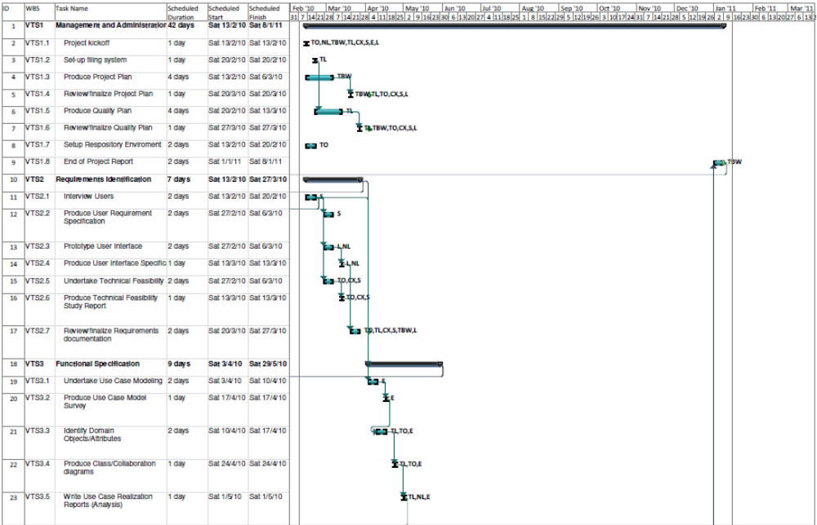

Figure 5.3 : Project Timescales – Page 2
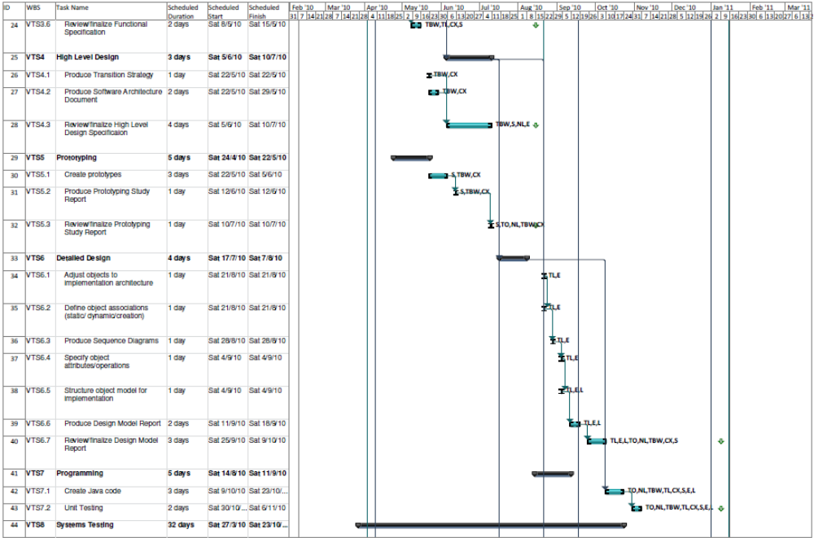

Figure 5.4 : Project Timescales – Page 3

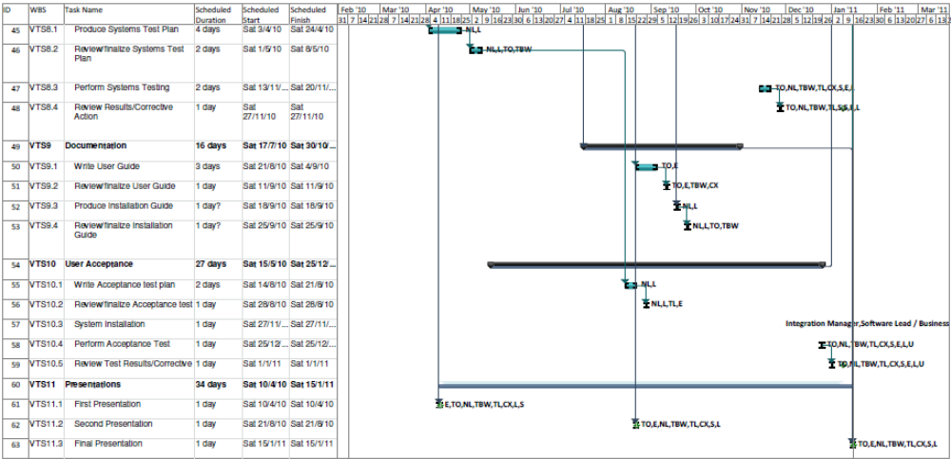

DELIVERABLES
As a result of undertaking the work described in this plan, the following deliverables will be produced by the project.

- Project Plan.
- QA Plan.
- User Requirement Specification.
- User Interface Specification
- Technical Feasibility Study Report
- Functional Specification.
- High-level Design Specification
- Prototyping Study Report
- Detailed Design Specification
- Source and Executable Code
- Test Documentation
- User Guide
- End of Project Report

- PROJECT TEAM STRUCTURE AND RESPONSIBILITIES
To undertake the work described in Section 3, the following staff will be used.

Project Manager : Teng Boon Wee
He will be responsible for producing the overall schedule of the entire project, and will also monitor the progress. He will also be responsible for producing the project plan as well as the the project filing system.
He will also be involved in producing of the Software Design Specification, the actual coding of the software, and the testing of the system.

Software Architect: Cai Xiang
He will be responsible for coming up with overall software architecture of the system. He will also take charge of doing a technical feasibility study of the third party APIs and software that will be used in the project. He will also be in charge for producing the design of the software.
He will also be involved in the actual coding of the software, and the testing of the system.

Test Manager: Plathottam Linu Thankam
She will be in charge of producing the User Interface Specification. She will also be responsible for planning for the system test and the user acceptance test. She will also take charge of the conducting of the two tests.
She will also be involved in producing the Software Design Specification, and the actual coding of the software.

Quality Manager: Kyaw Thu Lin
He will be responsible for producing the QA plan, as well as ensuring that the processes described in the QA plan are adhered to throughout the project.
He will also be involved in producing the Software Design Specification, the actual coding of the software as well as the testing of the system.

Configuration Manager: Oh Chew Key
He will be responsible for setting the environment required for the development of the system.
He will also be involved in undertaking the Technical Feasibility Study, producing software prototypes and the Prototyping Study Report, the actual coding of the software, the writing of the User Guide, the installation of the system on the test machines, the user training and also the testing of the system.

Integration Manager: Naung Naung Latt
He will be responsible for ensuring that different code modules will be able to work seamlessly with each other. He will also be in charge of the installation of the system on the test machines, as well as the user training.
He will also be involved in producing the User Interface Specification, the actual coding of the software and the testing of the system.

Technical Writer: Erik Araojo
He will be in charge of producing the User Guide. He will ensure that the User Guide will be written in such a way such that it can be easy understood by readers who may have little technical knowledge.
He will also be involved in producing the Software Design Specification, the actual coding of the system as well as the testing of the system.

Software Lead/Business Analysis: Li Pengfei
He will be responsible for gathering requirements from the users, and documenting these requirements in the User Requirements Specification document. He will also in charge of producing the software prototypes and producing the Prototyping Study Report. He will also be in charge of the actual coding of the software.
He will also be involved in producing the Technical Feasibility Study Report, producing the Software Design Specification and the testing of the system.

RESOURCES
The supporting resources required to enable the project team to undertake the activities specified in Section 3 are described as belows:

Accommodation
The development work will be done on the desktop machines available in the Insitute of System Science (ISS). No additional office space is required.

Computer Hardware and Software
The desktop machines available in ISS will be used to perform the coding and documentation tasks. The following software applications are required:
Windows OS
Java SDK
Java IDE
Microsoft Word
Version Control Software

The Project Manager will also make use of Microsoft Project as a tracking tool to keep track of the schedule.

Project Estimate
The man effort costing estimate for this project is attached in Appendix A. The estimate is derived by function point counting, using the COCOMO model to calculate the final estimate.

Risk Assessment and Management
A risk assessment matrix is attached in Appendix B. This matrix will list out the possible risks in the project, the priorities of the risks, and the actions to be taken for these risks.

- Data Function

  - Admin Portal
Internal Logical File/External Interface File |  |  | Elements of complexity
Type | Reference | Description | DET | RET | Complexity
ILF | 3.1.2.1 | User Data | 5 | 2 | L
 |  | - User name
 |  | - Password
 |  | - Role
 |  | - Email address
 |  | - Group
ILF | 3.1.2.2 | Group Data | 2 | 1 | L
 |  | - Group name
 |  | - Description
ILF | 3.1.2.4 | Track Data | 7 | 2 | L
 |  | - Track name
 |  | - Layer
 |  | - Longitude
 |  | - Latitude
 |  | - Timestamp of last update
 |  | - Layer attribute values
 |  | - Group
ILF | 3.1.2.5 | Layer Data | 4 | 1 | L
 |  | - Layer name
 |  | - Description
 |  | - Plugin for Tracking Client
 |  | - Plugin for Display Client
ILF | 3.1.2.6 | Layer Attribue Data | 5 | 2 | L
 |  | - Attribute name
 |  | - Description
 |  | - Data type
 |  | - Required
 |  | - Layer name
ILF | 3.1.2.7 | Layer Attribute Value | 3 | 1 | L
 |  | - Track name
 |  | - Attribute name
 |  | - Value

  - Tracking Client
Internal Logical File/External Interface File |  |  | Elements of complexity
Type | Reference | Description | DET | RET | Complexity
ILF | 3.3.1.2 | Tracking Client Config File | 2 | 1 | L
 |  | - Property name
 |  | - Property value
EIF | 3.3.1.1 | Get GPS data | 3 | 1 | L
 |  | - Latitude
 |  | - Longitude
 |  | - Timestamp

  - Display Client
Internal Logical File/External Interface File |  |  | Elements of complexity
Type | Reference | Description | DET | RET | Complexity
ILF | 3.4.1.17 | Display Client Config File | 2 | 1 | L
 |  | - Property name
 |  | - Property value

- Data Transactions

  - Admin Portal
Input/Output/Enquiry |  |  | Elements of complexity
Type | Reference | Description | DET | FTR | Complexity
EI | 3.1.1.2 | Create User | 5 | 2 | A
 |  | - User name
 |  | - Password
 |  | - Role
 |  | - Email
 |  | - Group
EI | 3.1.1.2 | Delete User | 1 | 1 | L
 |  | - User name
EI | 3.1.1.2 | Modify User | 5 | 2 | A
 |  | - User name
 |  | - Password
 |  | - Role
 |  | - Email
 |  | - Group
EI | 3.1.1.3 | Create Group | 2 | 1 | L
 |  | - Group name
 |  | - Description
EI | 3.1.1.3 | Delete Group | 1 | 2 | L
 |  | - Group name
EI | 3.1.1.3 | Modify Group | 2 | 1 | L
 |  | - Group name
 |  | - Description
EI | 3.1.1.5 | Assign Group to Track | 2 | 2 | L
 |  | - Track name
 |  | - Group
EI | 3.1.1.6 | Create Layer | 4 | 2 | L
 |  | - Layer name
 |  | - Description
 |  | - Plugin for Tracking Client
 |  | - Plugin for Display Client
EI | 3.1.1.6 | Modify Layer | 4 | 2 | L
 |  | - Layer name
 |  | - Description
 |  | - Plugin for Tracking Client
 |  | - Plugin for Display Client
EI | 3.1.1.6 | Delete Layer | 1 | 1 | L
 |  | - Layer name
EI | 3.1.1.6 | Create Layer Attributes | 5 | 2 | A
 |  | - Attribute name
 |  | - Description
 |  | - Data type
 |  | - Required
 |  | - Layer name
EI | 3.1.1.6 | Modify Layer Attributes | 5 | 2 | A
 |  | - Attribute name
 |  | - Description
 |  | - Data type
 |  | - Required
 |  | - Layer name
EI | 3.1.1.6 | Delete Layer Attributes | 1 | 1 | L
 |  | - Layer attribute name
EI | 3.1.1.9 | Change Password (Admin Portal) | 2 | 1 | L
 |  | - User name
 |  | - Password
EI | 3.1.1.4 | Create track (Admin portal) | 8 | 2 | A
 |  | - Track name
 |  | - Track Name
 |  | - Layer
 |  | - Longitude
 |  | - Latitude
 |  | - Layer attribute name
 |  | - Layer attribute value
 |  | - Group
EI | 3.1.1.4 | Update track (Admin portal) | 8 | 2 | A
 |  | - Track name
 |  | - Track Name
 |  | - Layer
 |  | - Longitude
 |  | - Latitude
 |  | - Layer attribute name
 |  | - Layer attribute value
 |  | - Group
EI | 3.1.1.4 | Delete track (Admin portal) | 1 | 2 | L
 |  | - Track name

Input/Output/Enquiry |  |  | Elements of complexity
Type | Reference | Description | DET | FTR | Complexity
EQ | 3.1.1.1 | User Login (Display portal) | 2 | 1 | L
 |  | Input
 |  | - User name
 |  | - Password

  - Display Client
Input/Output/Enquiry |  |  | Elements of complexity
Type | Reference | Description | DET | FTR | Complexity
EI | 3.4.1.19 | Change Password | 2 | 1 | L
 |  | - User name
 |  | - Password
EI | 3.4.1.20 | Reset Password | 1 | 1 | L
 |  | - User name
EI | 3.4.1.6 | Change Map Colour | 3 | 1 | L
 |  | - Map layer
 |  | - Line colour
 |  | - Fill colour
EI | 3.4.1.8 | Change map visibility | 2 | 1 | L
 |  | - Map layer
 |  | - Visible
EI | 3.4.1.9 | Change automatic map hide setting | 2 | 1 | L
 |  | - Map layer
 |  | - Zoom level to hide map
EI | 3.4.1.10 | Change tracking layer visibility | 2 | 1 | L
 |  | - Tracking layer
 |  | - Visible
EI | 3.4.1.11 | Change default symbol | 5 | 2 | A
 |  | - Tracking layer
 |  | - Attribute
 |  | - Attribute value
 |  | - Symbol
 |  | - Colour
EI | 3.4.1.12 | Change symbols | 5 | 2 | A
 |  | - Tracking layer
 |  | - Attribute
 |  | - Attribute value
 |  | - Symbol
 |  | - Colour
EI | 3.4.1.14 | Create Track | 8 | 2 | A
 |  | - Track name
 |  | - Track Name
 |  | - Layer
 |  | - Longitude
 |  | - Latitude
 |  | - Layer attribute name
 |  | - Layer attribute value
 |  | - Group
EI | 3.4.1.12 | Update Track | 8 | 2 | A
 |  | - Track name
 |  | - Track Name
 |  | - Layer
 |  | - Longitude
 |  | - Latitude
 |  | - Layer attribute name
 |  | - Layer attribute value
 |  | - Group
EI | 3.4.1.12 | Delete Track | 1 | 2 | L
 |  | - Track name

Input/Output/Enquiry |  |  | Elements of complexity
Type | Reference | Description | DET | FTR | Complexity
EO | 3.4.1.2 | Display Track | 9 | 4 | H
 |  | - Track identification
 |  | - Track name
 |  | - Layer
 |  | - Longitude
 |  | - Latitude
 |  | - Timestamp of last update
 |  | - Layer attribute values
 |  | - Symbol
 |  | - Colour

Input/Output/Enquiry |  |  | Elements of complexity
Type | Reference | Description | DET | FTR | Complexity
EQ | 3.4.1.16 | Search Track |  |  | H
 |  | Input | 7 | 3
 |  | - Track name
 |  | - Layer
 |  | - Longitude
 |  | - Latitude
 |  | - Timestamp of last update
 |  | - Layer attribute values
 |  | - Group identification
 |  | Output | 8 | 3
 |  | - Track name
 |  | - Track name
 |  | - Layer
 |  | - Longitude
 |  | - Latitude
 |  | - Timestamp of last update
 |  | - Layer attribute values
 |  | - Group name
EQ | 3.4.1.4 | Display Track Details |  |  | A
 |  | Input | 1 | 1
 |  | - Track name
 |  | Output | 7 | 3
 |  | - Track name
 |  | - Layer
 |  | - Longitude
 |  | - Latitude
 |  | - Timestamp of last update
 |  | - Layer attribute values
 |  | - Group name
EQ | 3.4.1.7 | Perform zoom on map |  |  | L
 |  | Input | 1 | 1
 |  | - Zoom level
 |  | Output | 1 | 1
 |  | - Map Change
EQ | 3.4.1.7 | Perform panning on map |  |  | L
 |  | Input | 2 | 1
 |  | - Latitude
 |  | - Longitude
 |  | Output | 1 | 1
 |  | - Map Change
EQ | 3.4.1.16 | Pan and Zoom to a Track | 2 | 1 | L
 |  | Input
 |  | - Track name
 |  | - Zoom level
 |  | Output | 2 | 1
 |  | - Map Change
EQ | 3.4.1.1 | User Login | 2 | 1 | L
 |  | - Input
 |  | - User name
 |  | Password

- Unadjusted Function Point Count Summary

  - Information Centre
ITEM | LOW | AVERAGE | HIGH | TOTAL
External Input | 11x3 =33 | 6x4 =24 | 0x6 =0 | 57
External Output | 0x4 =0 | 0x5 =0 | 0x7 =7 | 7
Internal File | 7x7 =49 | 0x10 =0 | 0x15 =0 | 49
Interface file | 1x5 =5 | 0x7 =0 | 0x10 =0 | 5
External Inquiry | 1x3 =3 | 0x4 =0 | 0x6 =6 | 3
 |  | Unadjusted | Function Points | = 121

  - Tracking Client
ITEM | LOW | AVERAGE | HIGH | TOTAL
External Input | 0x3 =0 | 0x4 =0 | 0x6 =0 | 0
External Output | 0x4 =0 | 0x5 =0 | 0x7 =0 | 0
Internal File | 1x7 =7 | 0x10 =0 | 0x15 =0 | 7
Interface file | 1x5 =5 | 0x7 =0 | 0x10 =0 | 5
External Inquiry | 0x3 =0 | 0x4 =0 | 0x6 =0 | 0
 |  | Unadjusted | Function Points | = 13

  - Display Client
ITEM | LOW | AVERAGE | HIGH | TOTAL
External Input | 7x3 =21 | 4x4 =16 | 0x6 =0 | 37
External Output | 0x4 =0 | 0x5 =0 | 1x7 =7 | 7
Internal File | 1x7 =7 | 0x10 =0 | 0x15 =0 | 7
Interface file | 0x5 =0 | 0x7 =0 | 0x10 =0 | 0
External Inquiry | 4x3 =12 | 1x4 =4 | 1x6 =6 | 22
 |  | Unadjusted | Function Points | = 66

- Value Adjustment Factor

CHARACTERISTIC | DI
Data Communications | 5 | Majority of vessel tracking operations done by exchange of data over the network.
Distributed Functions | 4 | Vessel data can be updated at the display clients, changes will be propagated to the server;  Server does consolidation of the data, changes to data will be propagated to the display clients.
Performance | 0 | No performance requirements specified.
Heavily Used configuration | 0 | Nothing specified.
Transaction Rate | 0 | No peak transaction period specified.
On-line Data Entry | 5 | > 30% of transactions processed interactively
End User efficiency | 3 | Standard windows application; No specific user requirements related to efficiency.
On-line Update | 3 | Update of vessel data over the network.
Complex Processing | 1 | Sensitive control and security processing – user rights based on login.
Re-usability | 1 | Use of third party APIs.
Installation Ease | 0 | Nothing specified.
Operational Ease | 0 | Nothing specified.
Multiple Sites | 2 | Should work for any machine running windows.
Facilitate Change | 0 | None specified.
Total Degree of Influence | 24

Adjustment Factor = 0.65 + (0.01 x 24) = 0.89

- Adjusted Function Point Count Summary

Adjusted FPC = Unadjusted FPC* Adjustment Factor
= (121 + 13 + 66) * 0.89
= 200 * 0.89
= 178

- Chosen Model and COCOMO II Scale factors

We shall use the EARLY DESIGN 2000 WATERFALL model when using the COSTAR 7 software tool

Scaling Factors | Description | Rating
PRECEDENTEDNESS | Majority of team has no prior experience in this domain. | 5
DEVELOPMENT FLEXIBILITY | Requirements are flexible enough to allow more than one way of implementing solution. | 2
ARCHITECTURE/RISK RESOLUTION | Some of the issues have been resolved. | 4
TEAM COHESION | Team is largely co-operative. | 2
PROCESS MATURITY | Based on RUP and will achieve a certain QA level. | 3

Cost Drivers |  | Rating
PERS |  | Nominal
PREX |  | Nominal
RCPX | Reliability – Basic, Complexity – High, Documentation – Nominal, Database - Large | High
RUSE |  | Nominal
PDIF |  | Nominal
FCIL |  | High
SCED |  | Nominal

- Using COSTAR for estimation

Taking all the figures derived from steps 1 to 6 and keying them into COSTAR, we get total 19.7 man months for the effort required, and 11.1 months for the duration.

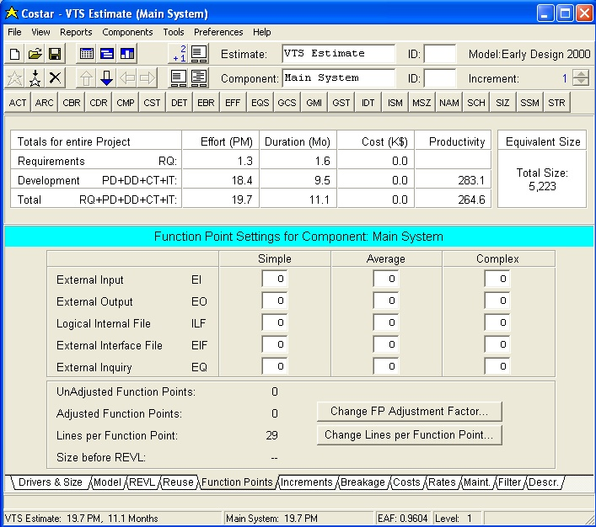
S/No | Risk | Description | Result of risk | Impact |  |  |  |  |  | Likelihood
 |  |  |  | 1 | 2 | 3 | 4 | 5 | Total | 1 | 2 | 3 | 4 | 5 | Total
1 | Leaving of team members | There is a possibility of team members leaving the team during the duration of the project. | The tasks of the team member who left the team will be left with no resource to complete them. |  | x | x |  |  | 2 |  | x | x | x | x | 4
2 | Lack of time commitment from team members | Team members may not be able to commit their time to the project as projected in the schedules, due to their work or personal issues. | The tasks of the team member will not be completed on time. |  | x | x |  |  | 2 |  | x | x | x | x | 4
3 | Lack of technical experience in Java | The majority of the team members do not have extensive experience in Java programming. | The time needed by the members to do programming will be longer as compared to the time required by experienced Java programmers. |  | x | x | x | x | 4 |  | x | x | x | x | 4
4 | Team members lacking in domain knowledge | The majority of the team members have no prior experience in systems dealing with the domain of this project. | The designs produced by the team members may not be suitable or even relevant to the project. | x | x | x |  |  | 3 | x | x | x | x |  | 4
5 | Limitations of third party software and APIs | As the project will rely heavily on third party software and APIs, there lies a possibility of the system being unable to fulfil its requirements due to the limitations of the third party software and APIs. | It may not be possible to fulfil some of the requirements, or a lot of effort is required to work around the limitations. | x | x | x |  | x | 4 | x |  |  | x |  | 2
6 | Last minute changes by user | The user may request additional features, or for changes to be made to the design at late stages of the project. | Adding features or making changes to the design at a late stage of the project may increase the efforts drastically. |  | x | x | x |  | 3 | x |  |  | x |  | 2
7 | Solution not feasible | The solution designed to fulfill the requirements may be too complex and it may not be possible to implement the solution. | It may not be possible to fulfil some of the requirements. | x | x | x |  |  | 3 | x |  |  | x |  | 2
 |  |  |  | Impact |  |  |  |  |  | Likelihood
 |  |  |  | 1 - Reduced Functionality |  |  |  |  |  | 1 - Novelty
 |  |  |  | 2 - Increased Cost |  |  |  |  |  | 2 - Product History
 |  |  |  | 3 - Schedule Slippage |  |  |  |  |  | 3 - Project Team History
 |  |  |  | 4 - Quality Cost |  |  |  |  |  | 4 - Recognised Authority
 |  |  |  | 5 - Performance |  |  |  |  |  | 5 - Expectation

Priority | Risk | Strategy | Action
1. | Lack of technical experience in Java | Minimization | Internal crossing training by the more expericed members
2. | Team members lacking in domain knowledge | Minimization | Internal crossing training by the more expericed members
3. | Leaving of team members | Insurance | Shadowing of members - Task of each user shall be shadowed by another member to ensure continuity in the case that a team member leaves the project.
4. | Lack of time commitment from team members | Insurance | Shadowing of members - Task of each user shall be shadowed by another member to ensure continuity in the case that a team member leaves the project.
5. | Limitations of third party software and APIs | Avoidance | Conducting of Technical Feasibility Study to ensure that the software and API chosen are suitable.
6. | Last minute changes by user | Avoidance | Going through the URS with the user, and coming up with the UI Specification.
7. | Solution not feasible | Avoidance | Conducting of Technical Feasibility Study to ensure that the software and API chosen are suitable.

Approval Record ISS/Forms/Approval

Project Name Vessel Tracking System
Document Ref ISS/FCS2/MP.2/1
Approved by | Date
Authorised by | Date
The document authorisation appears on the title page.
The structure of the publication is logical.
The distribution list is correct.
The title page is signed.
Calculations appear reasonable, are neatly presented and have been checked.
Theory and formulae are correct and properly applied.
Illustrations are relevant, readable and logically placed.
There are no typographical errors.
Units are consistent throughout.
The security classification is correct.
There are no obvious omissions.
The document complies with the Client's requirements, however specified.
Responsibility is accepted for all opinions, conclusions and recommendations.
The document does not run counter to company policy.

